Confusion Matrix:

A confusion matrix is extremely useful in classification problems because it gives a detailed view of model performance beyond just the overall accuracy. Here's why it's important and useful:
✅ 1. Breaks Down Predictions into Four Key Outcomes
It shows how your model performs in terms of:
- True Positives (TP): Correctly predicted positive class
- True Negatives (TN): Correctly predicted negative class
- False Positives (FP): Incorrectly predicted positive (Type I error)
- False Negatives (FN): Incorrectly predicted negative (Type II error)
This helps you understand what kind of mistakes your model is making.

✅ 2. Enables Deeper Performance Metrics
From the matrix, you can calculate:
- Accuracy: Overall correctness
- Precision: How many predicted positives were correct
- Recall (Sensitivity): How many actual positives were captured
- Specificity: How many actual negatives were correctly identified
- F1 Score: Balance between precision and recall
These metrics help you choose the right model for your specific business or medical use case.

✅ 3. Helps with Imbalanced Datasets
When classes are imbalanced (e.g., 95% healthy, 5% sick), accuracy alone can be misleading. The confusion matrix helps highlight if the model is just predicting the majority class and ignoring the minority.

✅ 4. Supports Business Decisions
For example:
- In fraud detection, you may want high recall to catch all frauds, even if a few false alarms happen.
- In email spam detection, you may prefer high precision to avoid putting good emails in spam.
The matrix tells you which trade-offs your model is making.

✅ 5. Allows Model Comparison and Tuning
By analyzing confusion matrices across models or tuning stages, you can:
- Detect overfitting/underfitting
- Improve classification thresholds
- Choose the best model for deployment

In short:
🟨 A confusion matrix doesn't just say if your model is right or wrong—it tells you how and where it's making mistakes, and what to fix or optimize.

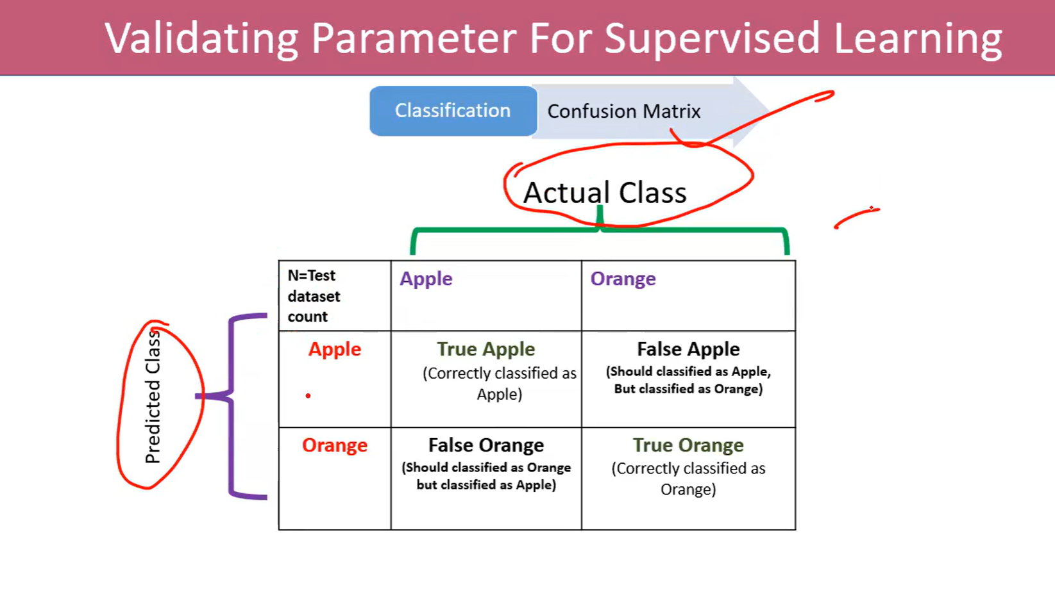
Key Terms You Should Know:
- True Positive (TP):
You predicted Apple, and it actually was an Apple.
- True Negative (TN):
You predicted Orange, and it actually was an Orange.
- False Positive (FP):
You predicted Apple, but it was actually an Orange. (A "Type I Error")
- False Negative (FN):
You predicted Orange, but it was actually an Apple. (A "Type II Error")

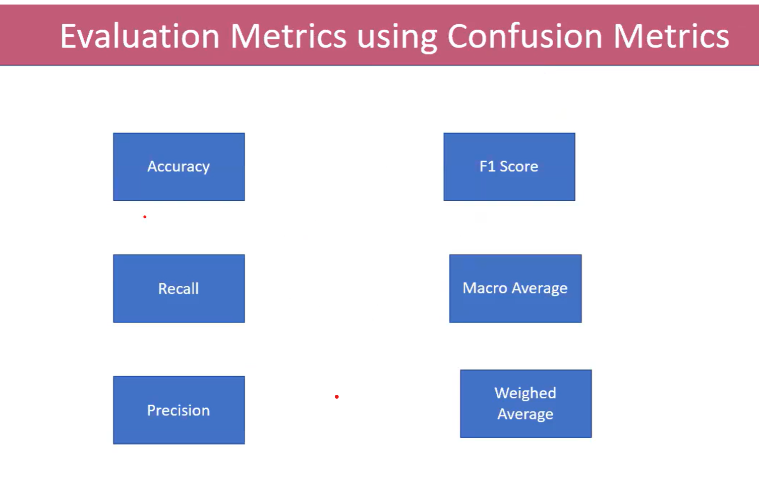

Accuracy:
✅ Overall correctness of your model. (Overall performance)
What is the percentage of correct classification of both (apple & orange) to the total input of the test set?

Accuracy = TP + TN / TP+TN+FP+FN

🗣️ 1. Everyday Language Questions About Accuracy
User Might Say | What They Likely Mean
“How well does it work?” | Asking about overall accuracy or performance
“Does it make mistakes?” | Curious about false positives/negatives
“Can I trust its results?” | Asking if predictions are usually correct
“How often is it right?” | Literally asking for accuracy (TP + TN) / total
“What’s the success rate?” | Another way of asking about accuracy
“Does it confuse apples and oranges?” | Asking about classification errors
“How reliable is it?” | A general question about consistent performance
“Is it better than guessing?” | Comparing model accuracy to random or naive baseline
“How many times does it get it wrong?” | Interested in errors: FP + FN

✅ 2. Recall (or Sensitivity, or True Positive Rate)
Out of all the actual Apples, how many did you correctly predict?
What is the percentage of correct classification of (Apple) to the total input of (Apple) in the test set?
What is the percentage of correct classification of (Orange) to the total input of (Orange ) in the test set?

Recall = TP/TP+FN
✅ 3. Precision (for Apple)
Out of all the things you predicted as Apple, how many were actually Apples?
Precision = TP/ TP+FP
✅ 4. F1 Score
Balance between Precision and Recall.
F1 Score = 2* precision * recall / (Precision +Recall)
🍊 Why These Matter
- High Precision: Your model avoids calling Oranges as Apples.
- High Recall: Your model catches (predicts) most of the Apples.
- F1 Score: Useful if you want a balance between catching all Apples and being sure of your predictions.
- Macro Average : Average performance of precision
- Weighted Average
- What is the sum of product of proportion rate(weight) of each class?

🧠 Tip for Beginners
- You don’t always need high accuracy alone. For example, if 90% of fruits are Oranges, a model that always predicts Orange will have high accuracy but be useless for finding Apples!

Category 1: Accuracy & General Interpretation

1. Email Spam Filter – 90% Accuracy
Q: Your model gives 90% accuracy for classifying emails as spam or not spam. However, users still complain about spam emails in their inbox. What could be going wrong?
A: The model may be misclassifying actual spam emails as non-spam (false negatives). If spam emails are underrepresented in the data, the model could have high accuracy by mostly predicting "not spam". Metrics like recall and precision for the spam class are more insightful.

2. COVID-19 Detection – 95% Accuracy
Q: Your COVID test model gives 95% accuracy, but many infected patients are missed. Why might accuracy be misleading?
A: If only 5% of patients are COVID-positive, a model predicting everyone as negative would still get 95% accuracy but miss all real cases. In such cases, recall (true positive rate) is critical.

3. Confusion Matrix Interpretation
Q: Given the matrix:

Predicted
Pos Neg
Actual Pos 70 30
Actual Neg 10 90

What is the accuracy?
A: Accuracy = (TP + TN) / Total = (70 + 90) / (70 + 30 + 10 + 90) = 160 / 200 = 80%.

4. Churn Prediction – Predicting No Churn Always
Q: A model always predicts "No Churn" and achieves 90% accuracy. Why is this not a good model?
A: It is likely ignoring the 10% who actually churn. Despite high accuracy, the recall for the "churn" class is 0. A better metric here would be F1 score or class-specific recall.

5. Comparing Models by F1 Score
Q: Model A: Accuracy = 85%, F1 = 70%. Model B: Accuracy = 82%, F1 = 76%. Which is better for fraud detection?
A: Model B is better. In fraud detection, balancing precision and recall is critical. F1 score captures this balance better than accuracy.

Category 2: Precision vs Recall

6. Spam Filter – High Precision
Q: Why is high precision important in a spam filter?
A: High precision ensures that emails marked as spam are truly spam, avoiding misclassification of important emails (false positives).

7. Cancer Test – Low Precision, High Recall
Q: What does low precision but high recall imply in a cancer test?
A: It means the model detects most cancer cases (few false negatives) but also raises many false alarms. It's acceptable early on, as missing cancer is more dangerous.

8. Loan Approval – Precision Calculation
Q: Matrix:

Predicted
App Deny
Actual App 80 20
Actual Deny 30 70

What is the precision for approved loans?
A: Precision = TP / (TP + FP) = 80 / (80 + 30) = 80 / 110 = ~72.7%.

9. Face Recognition for Security
Q: A false positive lets in an intruder. Should you prioritize precision or recall?
A: Precision. A high precision ensures that when access is granted, the person is truly authorized. False positives are a severe security risk.

10. Defect Detection – High Recall Trade-off
Q: Your model catches all defective products but wrongly flags many good ones. What's the cost?
A: Higher inspection/rework costs. While recall ensures all bad items are caught, low precision causes unnecessary action on good items.

Category 3: False Positives & False Negatives

11. Medical Test – False Negative Risk
Q: What is the danger of a false negative in a medical test?
A: The patient is wrongly told they are healthy, which can delay treatment and worsen outcomes.

12. Fire Alarm – False Positives
Q: False positives trigger fire alarms unnecessarily. Is this acceptable?
A: In most cases yes, as safety is prioritized. Better to have false alarms than miss a real fire (false negative).

13. Fraud Detection – False Positives
Q: What are the implications of many false positives in fraud detection?
A: Legitimate users face blocked transactions, leading to poor customer experience and possibly lost business.

14. Resume Screening – False Negatives

Q: Your resume screening model wrongly rejects good candidates. How do you measure and fix it?
A: Use recall for the "qualified" class. Improve by retraining with better features or reducing bias in training data.

15. Face Unlock – Serious Error Type
Q: Which is more serious: unlocking for the wrong person (FP) or not unlocking for the owner (FN)?
A: False positive is more serious due to privacy/security concerns. It's better to deny access (FN) than allow unauthorized entry.

Category 4: Imbalanced Classes

16. Disease Detection – Always Predict Healthy
Q: Why is always predicting "healthy" misleading when only 1% are sick?
A: Accuracy may be 99%, but the model misses all actual sick patients. Recall for the "sick" class is 0%.

17. Fraud Detection – Which Metrics?
Q: With 1 in 1000 cases being fraud, what metrics should you use?
A: Use precision, recall, F1 score, and ROC-AUC. Accuracy is not meaningful.

18. Fault Detection – Evaluating Model
Q: How do you evaluate performance in an imbalanced fault detection dataset?
A: Use class-wise metrics. Also consider using balanced accuracy, stratified sampling, or SMOTE to address imbalance.

19. Rare Disease Prediction – Fair Evaluation
Q: What techniques and metrics ensure fair evaluation of a rare disease model?
A: Use F1, precision-recall curves, and stratified cross-validation. Upsampling or synthetic data generation helps.

20. Cybersecurity Threats – Improving Model
Q: How can you improve model reliability on imbalanced cybersecurity threat data?
A: Combine threshold tuning, cost-sensitive learning, and anomaly detection. Monitor precision and recall during deployment.

Multi class

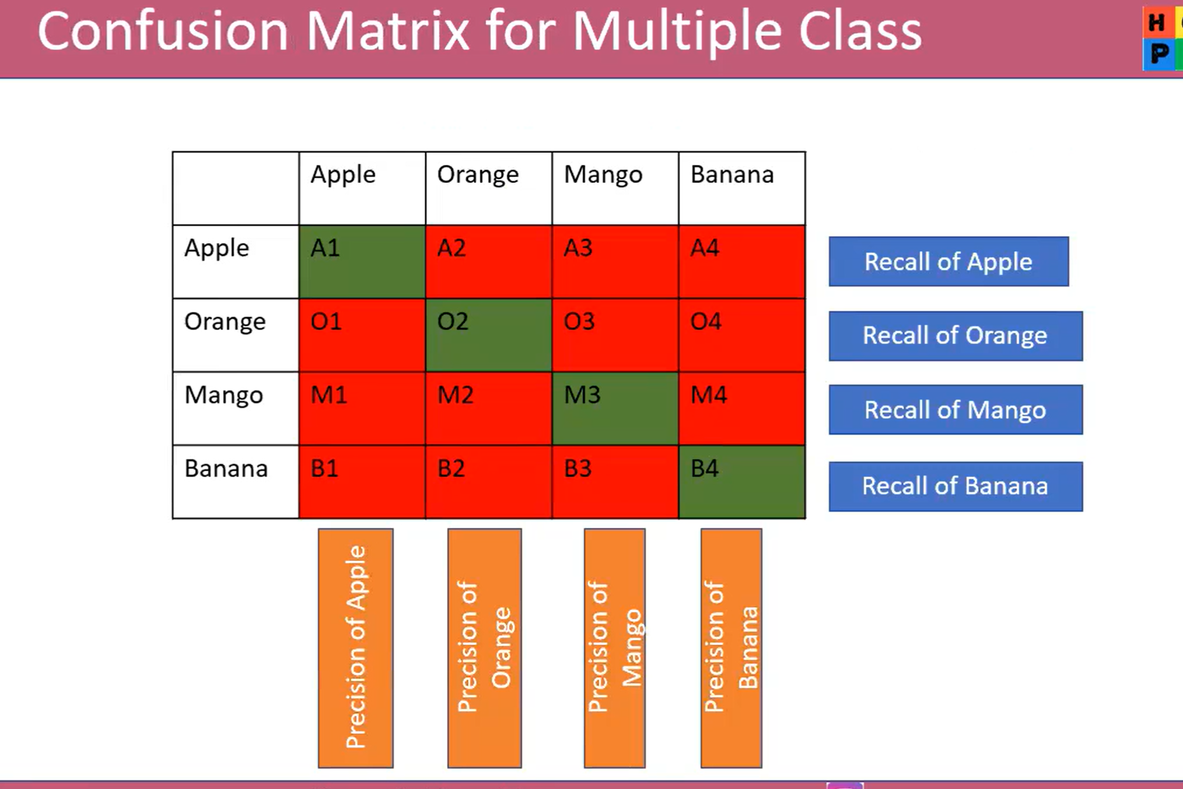

Let's express each scenario using a confusion matrix in the format you prefer:
mathematica
CopyEdit
Actual
| C | NC |
----------------------------
Predicted
C | | |
NC | | |
Where:
- C = Cancer
- NC = Non-Cancer
- Rows = Predicted values
- Columns = Actual values
Let’s plug in values for 4 different cases.

✅ 1. High Precision (few false positives)
mathematica
CopyEdit
Actual
| C | NC |
----------------------------
Predicted
C | 1 | 0 |
NC | 2 | 7 |
- TP = 1
- FP = 0
- FN = 2
- TN = 7
- Precision = 1.0
- Recall = 0.33

❌ 2. Low Precision (many false positives)
mathematica
CopyEdit
Actual
| C | NC |
----------------------------
Predicted
C | 2 | 3 |
NC | 1 | 4 |
- TP = 2
- FP = 3
- FN = 1
- TN = 4
- Precision = 0.40
- Recall = 0.67

🎯 3. High Recall (catch all actual cancer)
mathematica
CopyEdit
Actual
| C | NC |
----------------------------
Predicted
C | 3 | 2 |
NC | 0 | 5 |
- TP = 3
- FP = 2
- FN = 0
- TN = 5
- Precision = 0.60
- Recall = 1.0

🚫 4. Low Recall (miss most cancer cases)
mathematica
CopyEdit
Actual
| C | NC |
----------------------------
Predicted
C | 1 | 0 |
NC | 2 | 7 |
- TP = 1
- FP = 0
- FN = 2
- TN = 7
- Precision = 1.0
- Recall = 0.33

